1. **Insert the following document in collection products**

* **db.products.insert( { item: "card", qty: 15 } )**
* **db.products.insert( { _id: 10, item: "box", qty: 20 } )**
* **db.products.insert(**

**[**

**{ _id: 11, item: "pencil", qty: 50, type: "no.2" },**

**{ item: "pen", qty: 20 },**

**{ item: "eraser", qty: 25 }**

**]**

**)**

**Output:**

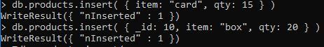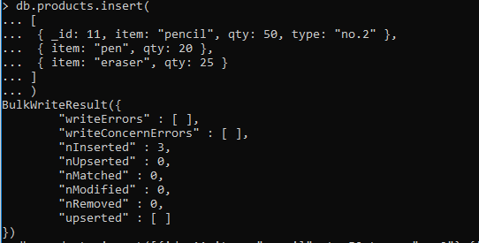

1. **Get your collection name from get collection method.**

**Output:**



1. **Find the documents in your collection.**

**Output:**

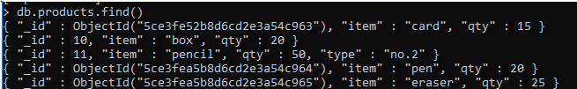

1. **Insert the following data in the collection inventory**

db.inventory.insertMany([

{ item: "journal", qty: 25, size: { h: 14, w: 21, uom: "cm" }, status: "A" },

{ item: "notebook", qty: 50, size: { h: 8.5, w: 11, uom: "in" }, status: "A" },

{ item: "paper", qty: 100, size: { h: 8.5, w: 11, uom: "in" }, status: "D" },

{ item: "planner", qty: 75, size: { h: 22.85, w: 30, uom: "cm" }, status: "D" },

{ item: "postcard", qty: 45, size: { h: 10, w: 15.25, uom: "cm" }, status: "A" }

]);

**Output:**

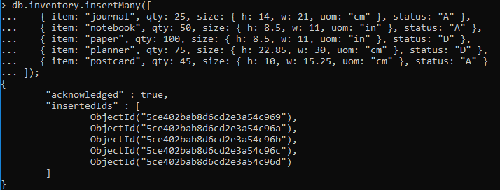

1. **Select from the inventory collection all documents where the status equals "D"**

**Output:**

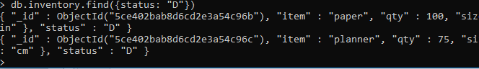

1. **Retrieves all documents from the inventory collection where status equals either "A"or "D":**

**Output:**

